**Concept Document**

**Fontys University of Applied Sciences**

**Semester 3**

|  |  |
| --- | --- |
| **Date** | **17/01/2024** |
| **Version** | **2.0** |
| **Status** | **Finished** |
| **Author** | **Group “MiMa”** |

**Versions**

|  |  |  |  |  |
| --- | --- | --- | --- | --- |
| **Version** | **Date** | **Author(s)** | **Amendments** | **Status** |
| 1.0 | 17/01/2024 | Mariyana Mileva, Mia Vasilevska | Creation of the concept document’s first version | Draft |
| 2.0 | 25/01/2024 | Mariyana Mileva | Updating the design of the document and updating the information in it | Finished |

**Contents**

**1.** **Introduction** 3

**2.** **Guidelines** 3

**3.** **Main Findings** 4

**3.1.** **Personas** 4

**3.2.** **Empathy Maps** 6

**3.3.** **User Journeys** 7

**3.4.** **POV & HMW** 8

**3.5.** **Task analysis** 9

**3.6.** **Heuristic Evaluation** 11

**3.7.** **Competitor analysis** 13

**4.** **Concept Visualization** 15

**4.1.** **Storyboard** 15

# **Introduction**

This document serves as a comprehensive overview for our university passion project. Our group name is "MiMa", and we are developing an innovative app. Our project focuses on creating a platform that facilitates connections for individuals seeking a gym buddy with whom they can work out.

Within this document, we aim to provide a detailed presentation of our concept, offering insights into the context and key findings. We'll walk you through our ideation process, allowing you to understand the evolution of our concept. Visual representations will enhance comprehension, offering a glimpse into the design and functionality of our proposed app.

This document is tailored for our instructors, peers, and potential users who share an interest in our project. By perusing this material, readers can gain insights into our vision, progress, and the upcoming iterations we plan to implement. We invite you to explore our journey as we work towards creating a meaningful and impactful solution for those seeking fitness companionship.

# **Guidelines**

* 1. Profile Setup

Start by creating an comprehensive profile that showcases your fitness interests, goals and preferred workout activities

* 1. Workout plan submission

Ensure that the submission is complete by filling in the following details:

* Title

Craft a brief descriptive title for the workout buddy profile

* Profile picture

Upload clear and relevant profile picture that represents you in a fitness context.

* Fitness preference

Specify your preferred workout activities, fitness level and any other relevant preferences.

* Availability

Indicate you availability, helping potential buddies find suitable times.

* Goals

Share your fitness goals.

# **Main Findings**

## **Personas**

In order to better understand our primary user, visualize them, and, most importantly, assist them in resolving their primary issue with our product, we constructed personas. Thus, this persona represents all students who have comparable problems and who need to enhance their learning processes as a whole.

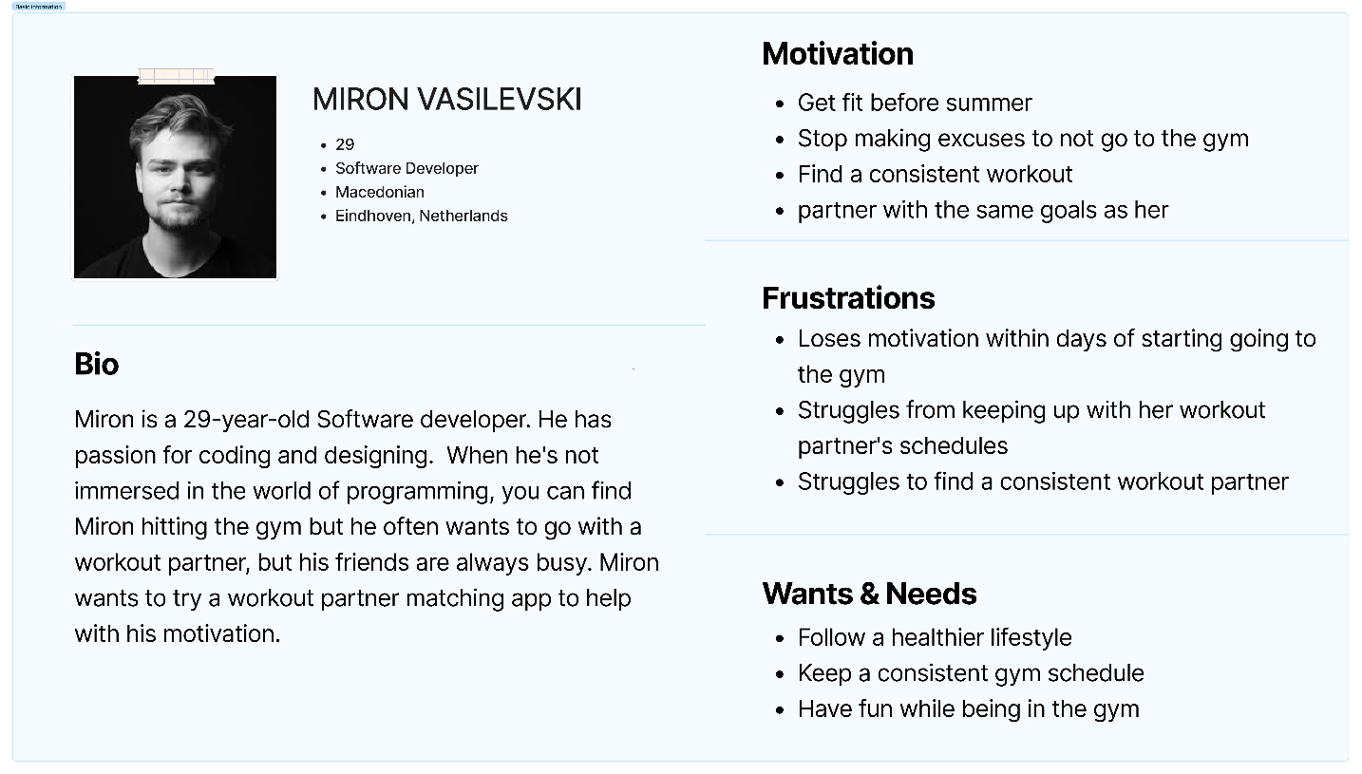**PERSONAS**

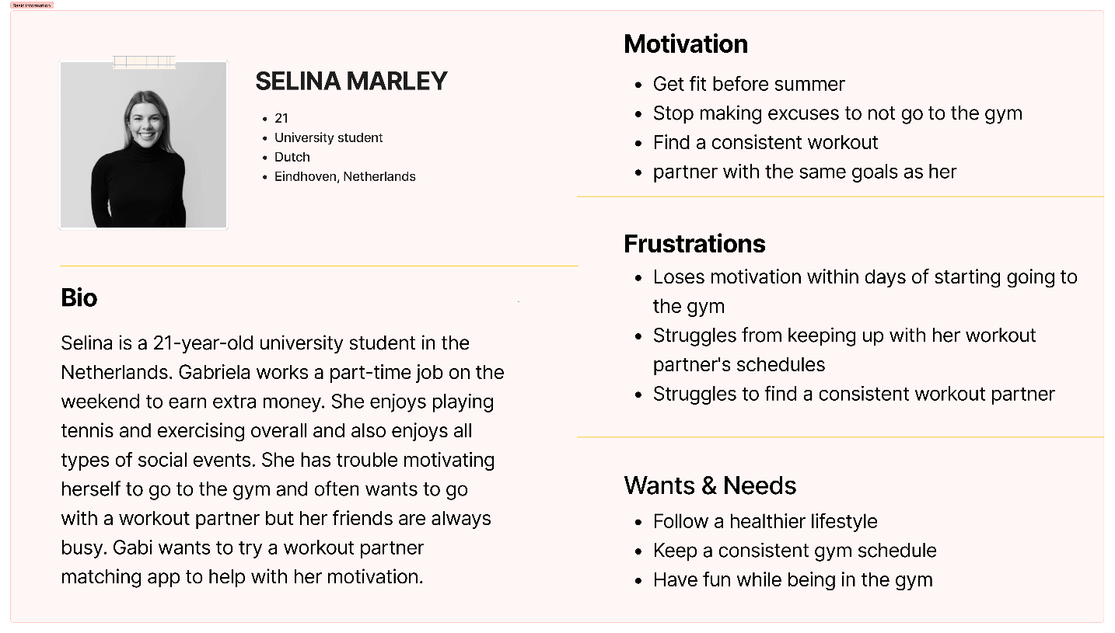

## **Empathy Maps**

Our team thought that the best way to present the findings of our survey and interviews is using an empathy map. We were able to summarize the major issues we need to address using the empathy map. It revealed to us the user's perspective on the issue at hand. Additionally, we gained a deeper knowledge of the user's attitudes toward digital substitutes. Because of that, we now have a general concept of how to approach the challenge at hand—creating a dynamic, enjoyable, and simple-to-use digital substitute.

**EMPATHY MAP**

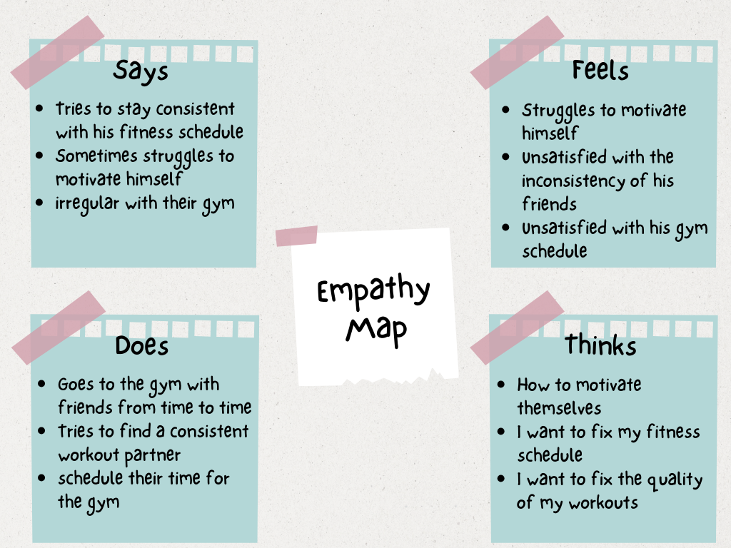

## **User Journeys**

We created two customer journey maps, for the two individual target groups (ICT and Media Design students and teachers) to better understand what the user would experience when he finds our platform. It displays the customer's prospective course of action and their opinion of the tool. This enabled us to concentrate more on its usability.

The first User Journey is from a teacher’s retrospective showcasing their experience with our platform. This detailed map illustrates the teacher's prospective course of action, highlighting key touchpoints and interactions. By understanding their journey, we can tailor our platform to meet the specific needs and expectations of educators, placing a strong emphasis on usability.

**USER JOURNEY**

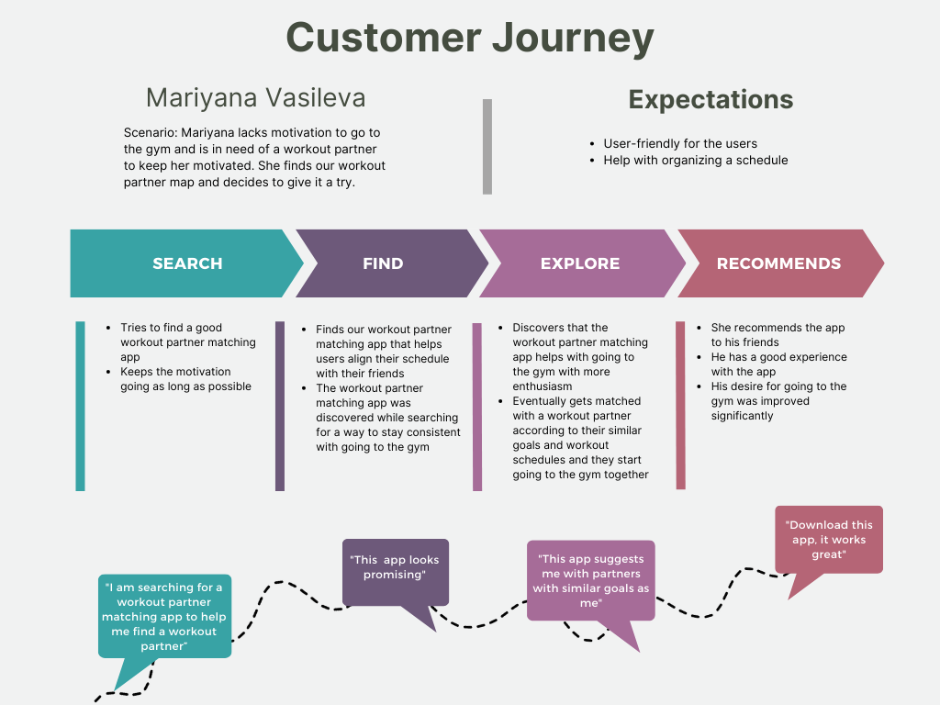

## **POV & HMW**

**Point of View**

As a student, I want to have access to a video lab platform that holds my projects so that I can showcase my creativity and get inspired by others.

**How Might We**

How might we design the video lab platform to encourage students to share their projects and collaborate with others?

## **Task analysis**

Conducting a task analysis was a crucial step in the development of our fitness companion app, MiMa. Task analysis allowed us to break down the complex process of user interactions into discrete tasks, providing a granular understanding of the actions users need to perform within the application. This systematic examination helped us identify specific functionalities required for the app, ensuring that each user task is accounted for and incorporated into the design and functionality. By analyzing the steps involved in profile setup, workout plan submission, and other key activities, we gained insights into user expectations and potential pain points.

**TASK ANALYSIS**

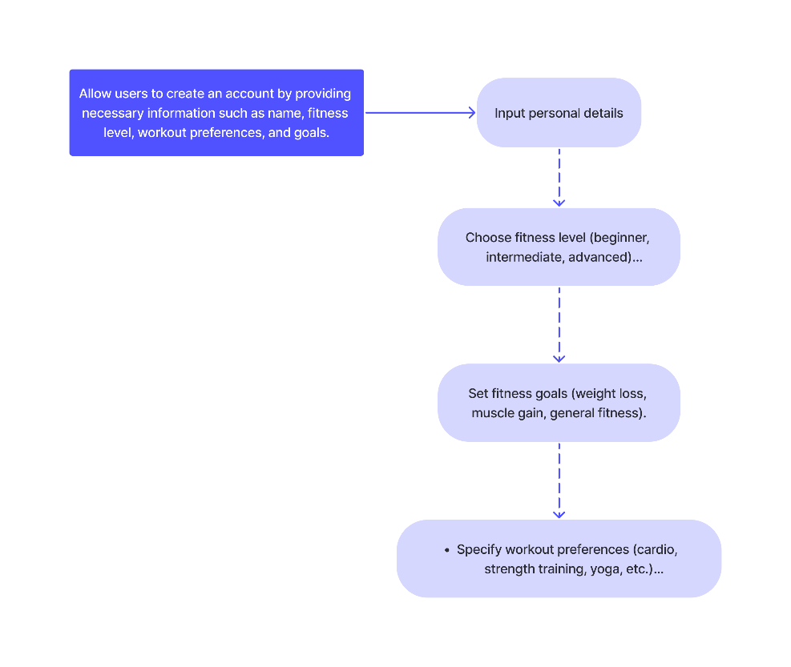

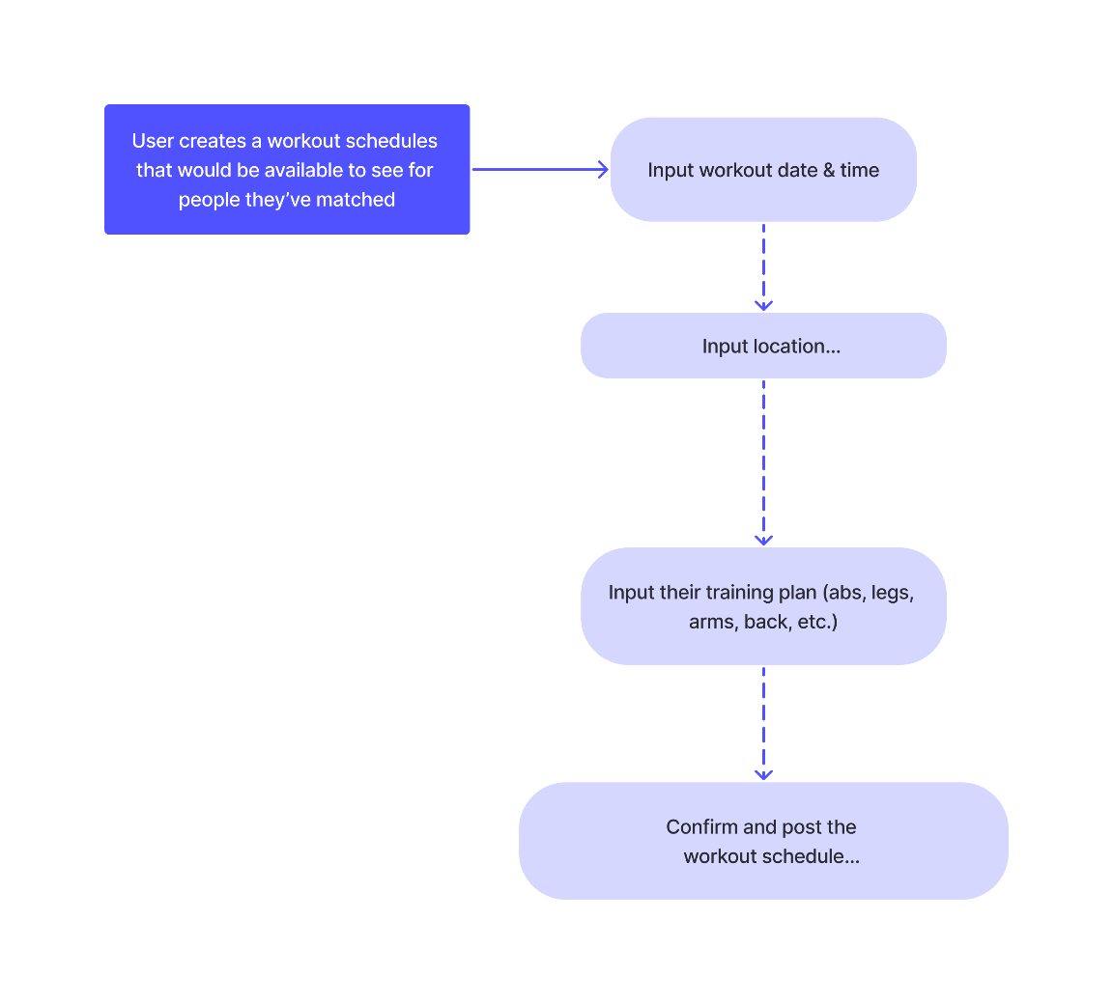

## **Heuristic Evaluation**

The heuristic evaluation was undertaken as a complementary step to the task analysis in the development of our fitness companion app, MiMa. While the task analysis provided a detailed breakdown of user interactions and workflows, the heuristic evaluation allowed us to assess the overall usability and user experience against established design principles. By applying Nielsen's heuristics, we systematically evaluated the app's interface for issues related to visibility, system status, user control, consistency, error prevention, and other usability factors.

**HEURISTIC EVALUATION**

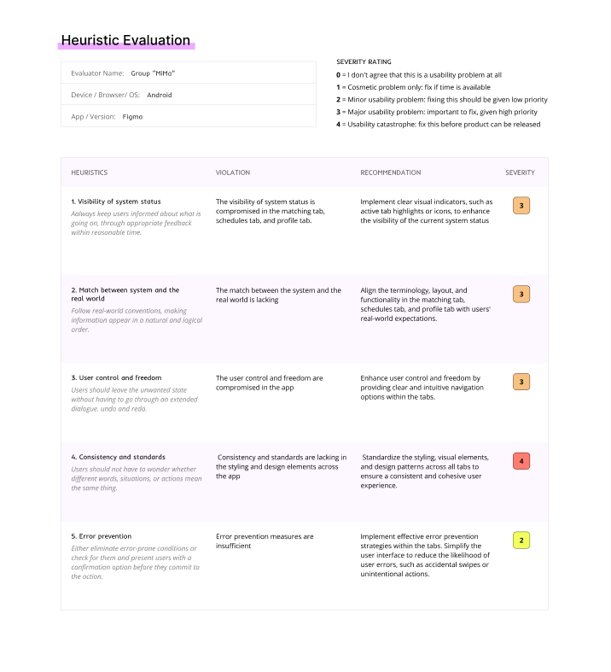

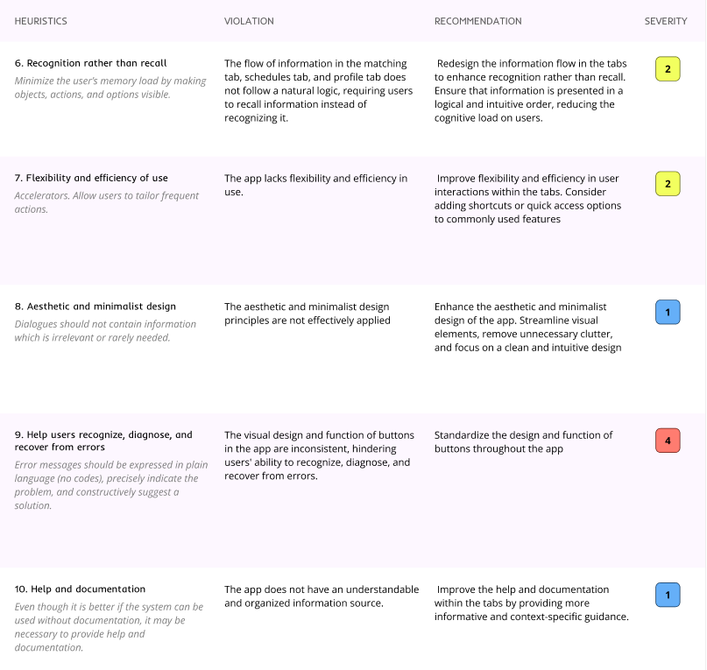

## **Competitor analysis**

The competitor analysis played a pivotal role in shaping the development strategy of our fitness companion app, MiMa. By conducting a thorough examination of competitors like Fitbit, MyFitnessPal, and Strava, we aimed to understand the strengths and weaknesses of existing solutions in the fitness companion space. The task analysis was instrumental in breaking down the functionalities of these competitor apps, allowing us to identify key features, user flows, and design patterns that resonated positively with users. This analysis served as a benchmark for our app's development, enabling us to leverage successful strategies, avoid potential pitfalls, and ultimately differentiate MiMa in a competitive market.

**COMPETITOR ANALYSIS**

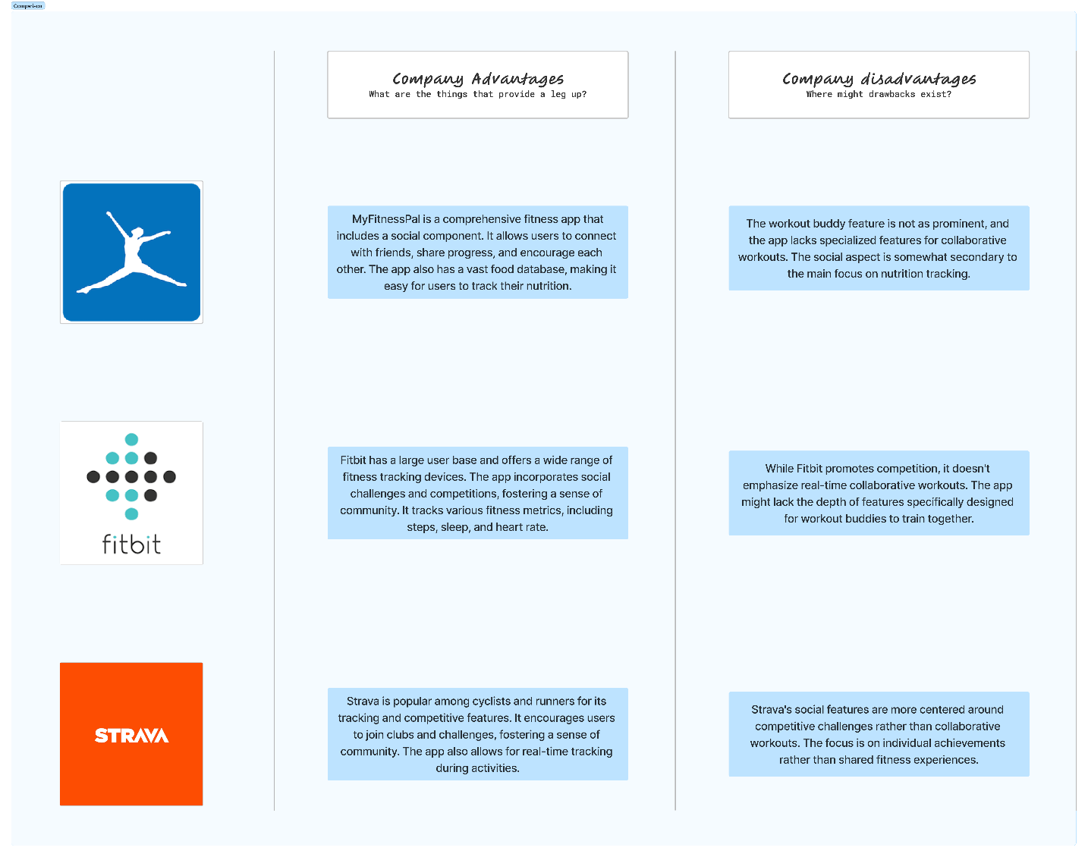

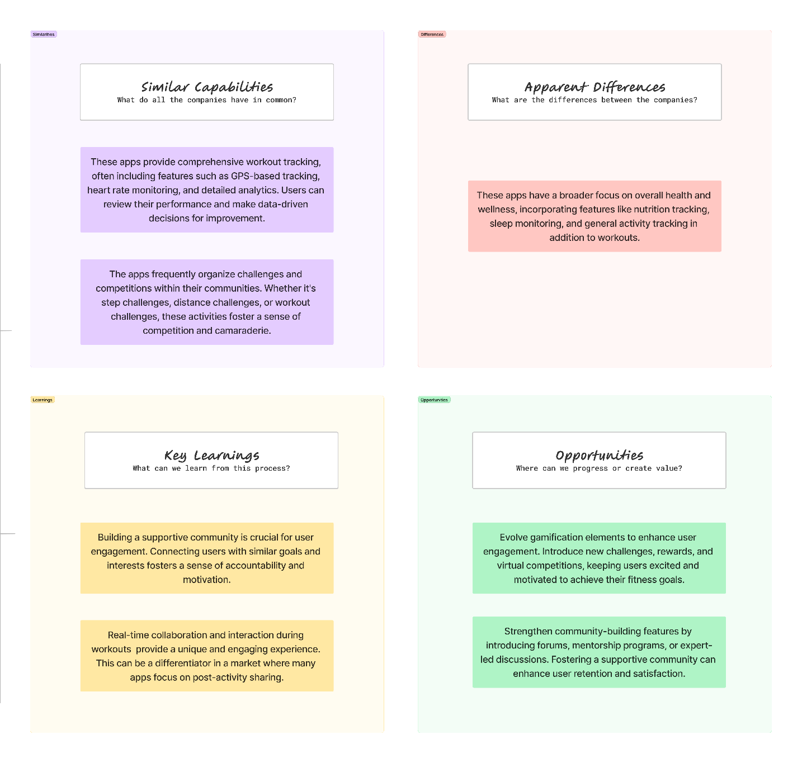

# **Concept Visualization**

## **Storyboard**

The next step was to see how a user might interact with our platform. For this we created a storyboard, setting up a potential scenario that would happen when a user interacts with our platform.

**STORYBOARD**

